**Periodic Table Definition:"The periodic table is a list of all elements in order of their atomic numbers."** Atoms differ from one another by their atomic weight and atomic number. Atoms are arranged in increasing atomic number on a chart known as the [periodic table of elements](http://chemistry.tutorcircle.com/inorganic-chemistry/periodic-table-of-elements.html).

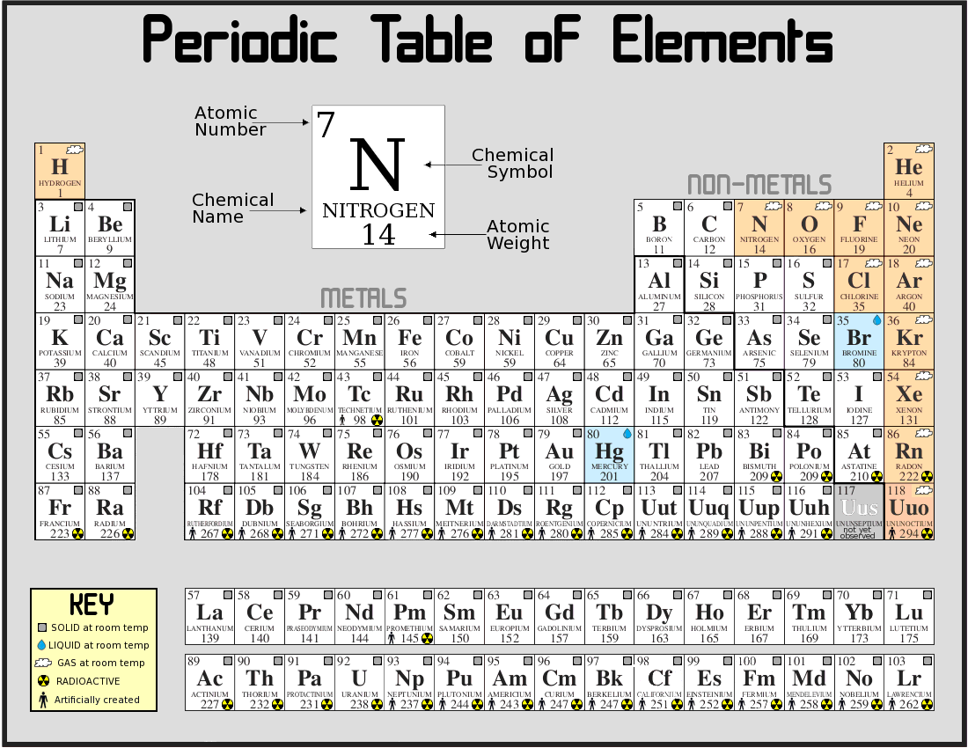

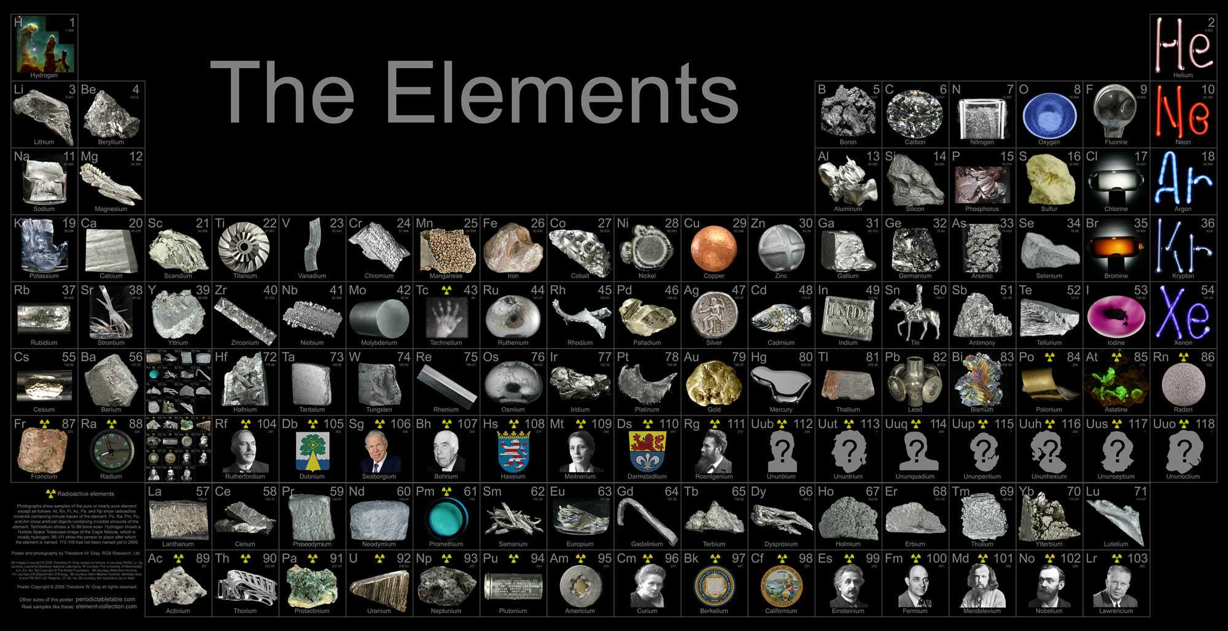

## *Periodic Table with Charges*

The metals of Groups 1A, 2A and 3A form ions having 1+, 2+ and 3+ charges that is their atoms lose electrons. Information about the charge of common ions can be obtained from the dynamic periodic table.

1. Elements in the first column (Group 1) of the periodic table form ions with a +1 charge.
2. Elements in the second column (Group 2) of the periodic table form ions with a +2 charge.
3. Generally speaking elements in Group 13 form ions with a +3 charge.
4. Oxygen and sulfur generally form ions with a -2 charge.
5. The halogens Group 17 form ions with a -1 charge.

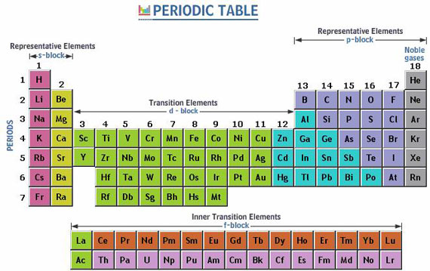

**Transition Elements**

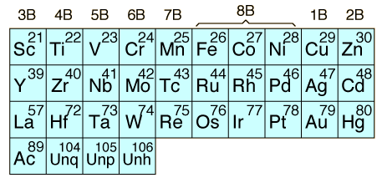

The elements that lie in between S-block and P-block are the d-block elements. These elements are called transition elements as they show transitional properties between s and p-block elements. These elements contain partially filled d-orbitals and hence they are called as d-block elements. The general electronic configuration of d-block elements is (n-1)d1-10ns1-2.

The transition elements are those elements having a partially filled d or f subshell in any common oxidation state. The term "transition elements" most commonly refers to the d-block transition elements. The transition elements include the important metals [iron](http://hyperphysics.phy-astr.gsu.edu/hbase/pertab/fe.html#c2), [copper](http://hyperphysics.phy-astr.gsu.edu/hbase/pertab/cu.html#c2) and [silver](http://hyperphysics.phy-astr.gsu.edu/hbase/pertab/ag.html#c2). Iron and titanium are the most abundant transition elements. Many catalysts for industrial reactions involve transition elements.

The elements zinc, cadmium and mercury do not strictly meet the defining properties, but are usually included with the transition elements because of their similar properties. The f-block transition elements are sometimes known as "inner transition elements". The first row of them is called the lanthanides or rare earths. The second row consists of the actinides. All of the actinides are radioactive and those above Z=92 are manmade in nuclear reactors or accelerators.

The general properties of the transition elements are

1. *They are usually high melting point metals .*
2. *They have several positive oxidation states.*
3. *They usually form colored compounds.*
4. *They are often paramagnetic.*
5. *They have a partly filled d-shell either as the element or in their compounds (apart from Zn).*
6. *Most are metals.*
7. *They are all shiny metals with the typical metallic grey / white colour, except gold, which is gold coloured, and copper, which is copper coloured.*
8. *They are all good conductors of heat and electricity.*
9. *They have high melting and boiling points.*
10. *Most transition metals form coloured compounds (apart from Sc and Zn).*
11. *They have several stable oxidation states or valencies.*
12. *Many are*[*used as catalysts*](http://www.sky-web.pwp.blueyonder.co.uk/Science/transitionmetalcatalysts.htm)*, either as the metal itself or as some of their compounds.*
13. *They form complex ions, with various co-ordination numbers and geometries.*
14. *Have low ionisation energy*

The transition metals are the group of metals in the middle section of the periodic table. They are divided into three groups - the first row transition metals, the second row transition metals and, guess what, the third row transition metals. The most commonly studied ones are the first row transition metals, listed in the table below.

|  |  |  |  |  |
| --- | --- | --- | --- | --- |
| **Symbol** | | **Name** | **Atomic Number** | **Electronic Configuration** |
|  | Sc | Scandium | 21 | 1s2, 2s2, 2p6, 3s2, 3p6, 4s2, 3d1 |
|  | Ti | Titanium | 22 | 1s2, 2s2, 2p6, 3s2, 3p6, 4s2, 3d2 |
|  | V | Vanadium | 23 | 1s2, 2s2, 2p6, 3s2, 3p6, 4s2, 3d3 |
|  | Cr | Chromium | 24 | 1s2, 2s2, 2p6, 3s2, 3p6, 4s1, 3d5 |
|  | Mn | Manganese | 25 | 1s2, 2s2, 2p6, 3s2, 3p6, 4s2, 3d5 |
|  | Fe | Iron | 26 | 1s2, 2s2, 2p6, 3s2, 3p6, 4s2, 3d6 |
|  | Co | Cobalt | 27 | 1s2, 2s2, 2p6, 3s2, 3p6, 4s2, 3d7 |
|  | Ni | Nickel | 28 | 1s2, 2s2, 2p6, 3s2, 3p6, 4s2, 3d8 |
|  | Cu | Copper | 29 | 1s2, 2s2, 2p6, 3s2, 3p6, 4s1, 3d10 |
|  | Zn | Zinc | 30 | 1s2, 2s2, 2p6, 3s2, 3p6, 4s2, 3d10 |

*Transition metals*

The elements belonging to d-block are metals. The d-block elements are classified into four transition series. These 4 series corresponds the filling of 3d, 4d, 5d and 6d orbitals.

### First transition series

This is also called as 3d series which corresponds the filling of 3d orbital. It starts from scandium whose atomic number is 21 and includes 10 elements till zinc whose atomic number is 30.

### First transition series (or) 3d series

| Element | Atomic number | Symbol | Electronic configuration |
| --- | --- | --- | --- |
| Scandium | 21 | Sc | [Ar] 3d1 4s2 |
| Titanium | 22 | Ti | [Ar] 3d2 4s2 |
| Vanadium | 23 | V | [Ar] 3d3 4s2 |
| Chromium | 24 | Cr | [Ar] 3d5 4s1 |
| Manganese | 25 | Mn | [Ar] 3d5 4s2 |
| Iron | 26 | Fe | [Ar] 3d64s2 |
| Cobalt | 27 | Co | [Ar] 3d7 4s2 |
| Nickel | 28 | Ni | [Ar] 3d8 4s2 |
| Copper | 29 | Cu | [Ar] 3d10 4s1 |
| Zinc | 30 | Zn | [Ar] 3d10 4s2 |

### 

### Second transition series

This is also called as 4d series which corresponds the filling of 4d orbital. It starts from yttrium whose atomic number is 39 and includes 10 elements till cadmium whose atomic number is 48.

### Second transition series (or) 4d series

| Element | Atomic Number | Symbol | Electronic configuration |
| --- | --- | --- | --- |
| Ytterium | 39 | Y | [Kr] 4d1 5s2 |
| Zirconium | 40 | Zr | [Kr] 4d2 5s2 |
| Niobium | 41 | Nb | [Kr] 4d4 5s1 |
| Molybdenum | 42 | Mo | [Kr] 4d5 5s1 |
| Technetium | 43 | Tc | [Kr] 4d5 5s2 |
| Ruthenium | 44 | Ru | [Kr] 4d7 5s1 |
| Rhodium | 45 | Rh | [Kr] 4d8 5s1 |
| Palladium | 46 | Pd | [Kr] 4d10 5s0 |
| Silver | 46 | Ag | [Kr] 4d10 5s1 |
| Cadmium | 48 | Cd | [Kr] 4d10 5s2 |

### Third transition series

This is also called as 5d series which corresponds the filling of 5d orbital. The first element of this series is lanthanum whose atomic number is 57 and includes 9 elements from hafnium whose atomic number is 72 to mercury whose atomic number is 80.

### Third transition series (or) 5d series

| Element | Atomic number | Symbol | Electronic configuration |
| --- | --- | --- | --- |
| Lanthanum | 57 | La | [Xe] 5d1 6s2 |
| Hafnium | 72 | Hf | [Xe] 4f14 5d2 6s2 |
| Tantalum | 73 | Ta | [Xe] 4f14 5d3 6s2 |
| Tungstun | 74 | W | [Xe] 4f14 5d4 6s2 |
| Rhenium | 75 | Re | [Xe] 4f14 5d5 6s2 |
| Osmium | 76 | Os | [Xe] 4f14 5d6 6s2 |
| Iridium | 77 | Ir | [Xe] 4f14 5d7 6s2 |
| Platinum | 78 | Pt | [Xe] 4f14 5d9 6s1 |
| Gold | 79 | Au | [Xe] 4f14 5d10 6s1 |
| Mercury | 80 | Hg | [Xe] 4f14 5d10 6s2 |

### 

### Fourth transition series

This is also called as 6d series which corresponds the filling of 6d orbitals.They are: actinium with atomic number 89 followed by elements with atomic numbers 104 to 110. This is an incomplete series.

| Element | Atomic No | Symbol | Electronic configuration |
| --- | --- | --- | --- |
| Actinium | 89 | Ac | [Rn] 6d1 7s2 |

### 

### General Characteristics of Transition Metals

All the transition metals except Zn, cd and Hg exhibit several physical and chemical properties. Some of their properties are discussed below:

### 1.Variable oxidation states

### By the study of electronic configuration of transition metals it is understood that variable oxidation state can be formed as there are both ns and (n-1)d electrons in bonding. The participation of ns electrons in bonding leads to +2 oxidation state which is a lower oxidation state. The participation of (n-1)d electrons in bonding leads to higher oxidation states like +3, +4, +5, +6 etc. These oxidation states depend upon the nature of combination of transition metals with other elements. The oxidation state increases with atomic number. This increase is related to groups. The most common oxidation state of the elements of first transition series is +2. Ionic bonds are formed in lower oxidation state transition elements whereas covalent bonds are formed in higher oxidation states.

The first row transition elements show variable oxidation states. Zn is an exception among them. As it has fully filled d-orbital, it exhibits only +2 oxidation state. The oxidation states of first row transition metals are shown below. Oxidation states of first row transition metals

**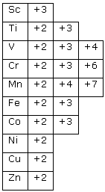**

### 

### 2.Magnetic properties

They generally contain one or more unpaired electrons in the (n-1)d orbital. Due to these unpaired electrons they behave as paramagnetic substances. These substances are attracted by the magnetic field. The transition elements that contain paired electrons behave as diamagnetic substances. These substances are repelled by the magnetic field. The paramagnetic character increases as the number of unpaired electrons increases.

### 3.Formation of colored compounds

Most of the transition elements form colored compounds both in solid state as well as in aqueous solution. It is already studied that the transition metals have incomplete d-orbital. The electrons are to be promoted from a lower energy level to a higher energy level. Some amount of energy is required for this process and the radiations of light are observed in the visible region. The compounds absorb a particular color from the radiation and the remaining ones are emitted. For e.g., Cu2+ are bluish green in color due to absorption of red light wavelength.As Zn has completely filled d-orbitals it cannot absorb radiation and hence Zn2+salts are white.

In the first row transition elements all the elements except Zn form colored ions. As these elements have incomplete d-orbital, some amount of energy is required to promote the electrons from lower energy level to higher energy level. This process exhibits radiations from which the compounds absorb a particular color. But some elements other than Zn also appear colorless depending on their oxidation state. For e.g., Sc3+, Ti4+ and Cu+ have completely filled d-orbitals and hence they appear colorless.

### 4.Formation of complexes

Transition metals form many complex ions. They are the electrically charged complexes with a metal ion in the center which is surrounded and linked by a number of neutral molecules or negative ions. These neutral molecules or negative ions are called as ligands. As the transitions metals are small in size they form large number of complexes.

All the first row transition elements form complexes. These complexes contain negative ions or neutral molecules linked to a metal ion. These are called as ligands. Some examples of the complex compounds formed by first row transition elements are:

[Fe(CN)6]4-, [Cu(NH3)4]2+, [Ni(CN)4]2-, [Zn(NH3)4]2+32+2+ .

### 5.Electrode potential and low reactivity

### The stability of the oxidation state of metal depends on the electrode potential.The electrode potential is a measure of the total enthalpy change (DHT) when a solid metal, M is brought into aqueous medium in the form of M+ (aq).

##### **electrode potential**

The total enthalpy change depends on sublimation energy, ionization energy and hydration energy of the metal.

##### **total enthalpy change**

When electrode potential is less the stability is more.

### 6. Metallic character

Most of the transition elements of the first row form metallic bonds due to the presence of incomplete outermost energy level. So, all the transition elements exhibit metallic characters. The strength of the metallic bond depends upon the number of unpaired d-electrons. As the number increases the strength also increases. Due to the absence of unpaired electrons 'Zn' is not a hard metal.

### 7.Ionization energy

The ionization energies of first row elements gradually increases with increase in atomic number. The ionization energy of Zn is very high than all the other metals which is due to its fully filled d-orbital. The third ionization energy of Mn is very high than the others.

##### 

### *8.Ionic radii*

In the first row transition elements the ionic radii decreases with increase in atomic number. The value of ionic radii also depends on the oxidation state of metals. As the oxidation state increases the ionic radii decreases and as the oxidation state decreases the ionic radii increases.

### 9.Catalytic property

The first row transition elements exhibit catalytic properties due to the presence of unpaired electrons which can form complexes. Iron and vanadium are the most important catalysts. Iron is used as catalyst in the manufacture of ammonia. Vanadium is used in the form of vanadium pentoxide in the manufacture of sulphuric acid.

### 

### 10.Interstitial compounds

All the first row transition metals form interstitial compounds with the elements of the S and P-blocks. The elements that occupy the interstitial sites in their lattices are H, C and N. Both the elements combine and form bonds which are hard.

### 11.Alloy formation

When one metal mixes up with another metal alloys are formed. As the d-block elements have same atomic sizes they can easily take up positions of one another. This causes alloy formation. For example: cr, V, Mn are used in formation of alloy steels.

## Transition Metals

## Electronic Configurations

The electronic configurations for the d-block elements are largely as expected, with 2 exceptions (Where [Ar] = 1s2 2s2 2p6 3s2 3p6):

|  |  |
| --- | --- |
|  |  |
| Sc | [Ar] 3d14s2 |
| Ti | [Ar] 3d24s2 |
| V | [Ar] 3d34s2 |
| **Cr** | **[Ar] 3d54s1** |
| Mn | [Ar] 3d54s2 |
| Fe | [Ar] 3d64s2 |
| Co | [Ar] 3d74s2 |
| Ni | [Ar] 3d84s2 |
| **Cu** | **[Ar] 3d104s1** |
| Zn | [Ar] 3d104s2 |

*A half full or a full 3d sub-shell gives extra stability to an atom. Therefore, for chromium and copper, the 4s sub-shell is only half filled to give this extra stability.*

## *Ions*

*Transition elements lose the 4s electrons before the 3d electrons when forming ions. As these sub-shells are very close together in energy levels, all transition metals are able to form ions with more than one oxidation number - manganese, for example, has ions in oxidation numbers from +1 to +7!*

## *Complexes*

*Transition metal ions are small and charged - they have a high charge density. They therefore attract molecules with lots of electrons, ligands, to form complex ions.****Ligands****are molecules or ions which bond to metal ions by forming dative covalent bonds with an empty d-orbital. A****complex ion****is a metal atom surrounded by ligands. The****coordination number****of a complex ion is the number of dative covalent bonds formed from ligand(s); this is not the same as the number of ligands because some molecules can form more than 1 dative covalent bond to a metal ion. These are called bidentate (e.g. ethane-1,2-diamine or ethanedioate ions) or multidentate (e.g. EDTA) ligands, rather than unidentate (e.g. ammonia, water, chloride) ligands.*

### *Shapes of Complex Ions*

*With small ligands, such as water, transition metal ions form octahedral complexes. This is because there are 6 ligands around a central metal ion which spread out as far as possible e.g. [Cu(H2O)6]2+, [Cr(NH3)6]3+. With larger ligands, such as chloride ions, this is not enough room for 6 ligands to fit around the metal ion, so a tetrahedral complex with 4 ligands is formed e.g. [CrCl4]-. There are also times when square planar complexes e.g. [Pt(NH3)2Cl2]/cisplatin, along with linear complexes e.g. [Ag(NH3)2]+/Tollens' reagent, or [CuCl2]- are formed. All the complexes here follow the VSEPR theory covered in AS chemistry.*

## *Coloured Ions*

*The 5 d orbitals point in different directions. For an isolated ion, all of these orbitals are at the same energy level. When ligands form dative covalent bonds to the metal ion, electrons in some of the orbitals will experience a greater repulsion than electrons in other orbitals. The 3d sub-shell is split, with one set of orbitals at a higher energy level and one at a lower energy level. The energy difference between these is the energy of a photon given out when electrons move to the lower energy orbitals. The energy difference and photon frequency is linked by:*

*[\Delta E = hf\ (\mathrm{or}\ \Delta E = hv\ \mathrm{where}\ v = f)](javascript:void(0))*

*[h = 6.63 \times 10^{-34}](javascript:void(0))*

*Electrons can only move between these energy levels when the d sub shell is neither full nor empty - this explains why scandium and zinc do not have coloured complexes. The energy difference depends on the oxidation state of the metal ion, the coordination number and number of ligands around the metal ion.*

*Transition metal complexes are also able to absorb light when electrons move into the higher energy orbitals. This is useful spectrometry (AQA only)*

*Transition metal ions can be identified by colour. The table below shows the aqua complexes of the transition metals for the common oxidation states:*

|  |  |  |  |  |  |  |  |  |  |
| --- | --- | --- | --- | --- | --- | --- | --- | --- | --- |
| ***Sc*** | ***Ti*** | ***V*** | ***Cr*** | ***Mn*** | ***Fe*** | ***Co*** | ***Ni*** | ***Cu*** | ***Zn*** |
| *+3 colourless* | *+3 violet* | *+3 blue* | *+3 green* | *+2 pale pink* | *+2 pale green* | *+2 pink* | *+2 green* | *+1 colourless* | *+2 colourless* |
|  |  | *+5 yellow* | *+6 yellow or orange, +2 blue1* | *+7 purple* | *+3 red-brown* |  |  |  |  |

*1Chromate (CrO4-) = yellow, dichromate (Cr2O72-) = orange*

## *Reactions of Complexes (Edexcel)*

*The following table shows the results of adding aqueous sodium hydroxide and ammonia to some transition metal ions:*

|  |  |  |  |
| --- | --- | --- | --- |
| ***Ion*** | ***Some NaOH or NH3*** | ***Excess NaOH*** | ***Excess NH3*** |
| ***Cr(III)*** | *Green or violet precipitate* | *Deep green solution* | *No change* |
| ***Mn(II)*** | *Buff precipitate which darkens in air as MnO2 forms* | *No change* | *No change* |
| ***Fe(II)*** | *Pale green precipitate which turns brown at surface due to oxidation to Fe(III)* | *No change* | *No change* |
| ***Fe(III)*** | *Red-brown precipitate* | *No change* | *No change* |
| ***Ni(II)*** | *Pale green precipitate* | *No change* | *Pale lavender-blue solution* |
| ***Cu(II)*** | *Pale blue precipitate* | *No change* | *Deep blue solution* |
| ***Zn(II)*** | *White precipitate* | *Colourless solution* | *Colourless solution* |

*The precipitates formed upon addition of some NaOH or NH3 all involve the formation of the hydroxide of the metal when hydrogen ions are pulled off the hexaaqua complexes of the ions in solution by the hydroxide ions from NaOH or NH4OH, e.g.:*

* *[\mathrm{Fe^{2+} + 2OH^- \longrightarrow Fe(OH)_2}](javascript:void(0))*
* *[\mathrm{Fe^{3+} + 3OH^- \longrightarrow Fe(OH)_3}](javascript:void(0))*

*The deep green solution of chromium in excess NaOH is due to:*

*[\mathrm{Cr(OH)_3 + 3OH^- \longrightarrow [Cr(OH)_6]^{3-}}](javascript:void(0))*

*The pale solution of nickel in excess NH3 is due to:*

*[\mathrm{Ni(OH)_2 + 6NH_3 \longrightarrow [Ni(NH_3)_6]^{2+} + 2OH^-}](javascript:void(0))*

*The blue solution of copper in excess NH3 is due to:*

*[\mathrm{Cu(OH)_2 + 4NH_3 + 2H_2O \longrightarrow [Cu(NH_3)_4(H_2O)_2]^{2+} + 2OH^-}](javascript:void(0))*

*The colourless solutions of zinc are due to:*

*[\mathrm{Zn(OH)_2) + 2OH^- \longrightarrow Zn(OH)_4^{2-}}](javascript:void(0))*

*[\mathrm{Zn(OH)_2) + 4NH_3 \longrightarrow [Zn(NH_3)_4]^{2+} + 2OH^-}](javascript:void(0))*

## *Use as Catalysts*

*Transition metals are used in industry as catalysts due to their variable oxidation states from the ability of the partially filled 3d orbitals to gain or lose electrons.*

### *Heterogeneous Catalysts (AQA)*

*Heterogeneous catalysts are ones which exist in a different phase from the reactants. Examples include:*

* *Pt, Pd, Rh in catalytic converters. These solid catalysts are supported on a ceramic honeycomb to maximise the surface area and minimise cost.*
* *V2O5 in the Contact Process:*

*[\mathrm{SO_2 + V_2O_5 \longrightarrow SO_3 + V_2O_4}](javascript:void(0))*

*[\mathrm{O_2 + 2V_2O_4 \longrightarrow V_2O_5}](javascript:void(0))*

*Vanadium changes between the +5 and +4 oxidation states.*

* *Cr2O3 to manufacture methanol from carbon monoxide and hydrogen.*
* *Fe in the Haber Process.*

*Although catalysts are not used up in the reactions they catalyse, they may get poisoned by impurities in the reactants and lose their efficiency. This means catalysts need to be replaced over time, which may get expensive as some of these metals are rare - e.g. lead poisons catalytic converters, and sulfur poisons iron in the Haber Process.*

### *Homogeneous Catalysts and Autocatalysis(AQA)*

*When a catalyst and the reactants are in the same phase, the catalyst is called a homogeneous catalyst. The catalyst reacts and is regenerated in the reaction:*

* *Fe2+ catalyses the reaction between I- and S2O82-:*

*[\mathrm{S_2O_8^{2-} + 2I^- \longrightarrow I_2 + 2SO_4^{2-}}](javascript:void(0))*

*[\mathrm{2S_2O_8^{2-} + 2Fe^{2+} \longrightarrow 2SO_4^{2-} + 2Fe^{3+}}](javascript:void(0))*

*[\mathrm{2Fe^{3+} + 2I^- \longrightarrow I_2 + 2Fe^{2+}}](javascript:void(0))*

*The overall reaction involves 2 negatively charged ions, which repel each other. The reactions with the iron catalyst involve oppositely charged ions, which make it easier for the reaction to take place.*

*Autocatalysis is when a reaction gives a product which catalyses the reaction itself:*

* *Mn2+ catalyses the reaction between C2O42- and MnO42-:*

*[\mathrm{2MnO_4^-_{(aq)} + 5C_2O_4^{2-}_{(aq)} + 8H^+_{(aq)} \longrightarrow 2Mn^{2+}_{(aq)} + 10CO_2_{(g)} + H_2O_{(l)}}](javascript:void(0))*

*The purple colour of manganate(VII) disappears slowly at first, but this increases in speed as more Mn2+ is produced.*

## *Applications of Complexes (AQA)*

* *Variable oxidation states are important in catalysts.*
* *Fe(II) in haemoglobin enables oxygen to be transported in the blood. CO is toxic as it binds to the iron very strongly, stopping it from being able to bind to oxygen to carry it around.*
* *Pt(II) in cisplatin is used as an anticancer drug. Benefits: treats cancers by triggering apoptosis. Risks: major side effects include kidney and nerve damage, hearing and hair loss.*
* *[Ag(NH3)2]+ is in Tollens' reagent to distinguish between aldehydes and ketones.*

*Inner Transition Elements*

*Lanthanides and Actinides*

Inner transition elements are those in which f-orbitals are progressively filled.. The elements of the two series at the bottom of the [periodic table](http://chemistry.tutorcircle.com/inorganic-chemistry/periodic-table.html) together form the f-block elements. The first row is referred to as the lanthanides the second row as the actinides. In lanthanoids 4f-orbitals and in actinides 5f-orbitals are filled up. All the elements in f-block are metals and they are also called inner transition elements .Some of the inner transition elements are synthetic not found in nature.

The atoms of f-block elements have their last three shells incompletely filled. The f-block consists of thirty elements.The lanthanides start with lanthanum which has the electron configuration [Xe] 5d6s2.

## *Inner Transition Metals Definition*

The type of element similar to the transition elements but differs from the regular transition elements in that they have three outermost incomplete shells called **inner transition elements**, they not only have incomplete d-levels but they also have incomplete f-levels.

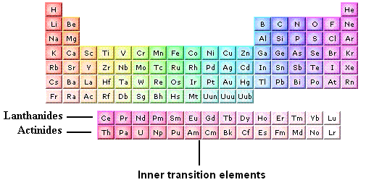

The two series are called lanthanides that have atomic atomic number from 57 to 71 and actinides having atomic numbers from 89 to 103. The series actinides contains some synthetic elements that do not occur in nature but are prepared in the laboratories. These synthetic elements exist for a brief period of time.  
  
The atoms of inner transition elements have their outermost three shells incompletely filled. The inner transition elements form the f-block elements.

## *Inner Transition Metals List*

|  |  |  |
| --- | --- | --- |
| **S.No** | **Element** | **Symbol** |
| 1 | Cerium | Ce |
| 2 | Praseodymium | Pr |
| 3 | Neodymium | Nd |
| 4 | Promethium | Pm |
| 5 | Samarium | Sm |
| 6 | Europium | Eu |
| 7 | Gadolinium | Gd |
| 8 | Terbium | Tb |
| 9 | Dysprosium | Dy |
| 10 | Holmium | Ho |
| 11 | Erbium | Er |
| 12 | Thulium | Tm |
| 13 | Ytterbium | Yb |
| 14 | Lutetium | Lu |

The list of inner transition elements comprising of **lanthanides**   
  
 List of inner transition elements **actinides** .

|  |  |  |
| --- | --- | --- |
| **S.No** | **Element** | **Symbol** |
| 1 | Thorium | Th |
| 2 | Protactinium | Pa |
| 3 | Uranium | U |
| 4 | Neptunium | Np |
| 5 | Plutonium | Pu |
| 6 | Americium | Am |
| 7 | Curium | Cm |
| 8 | Berkelium | Bk |
| 9 | Californium | Cf |
| 10 | Einsteinium | Es |
| 11 | Fermium | Fm |
| 12 | Mendelevium | Md |
| 13 | Nobelium | No |
| 14 | Lawrencium | Lr |

## *Inner Transition Metals Properties*

The Inner [Transition Metals](http://chemistry.tutorcircle.com/inorganic-chemistry/transition-metals.html) Characteristics are given below.  
  
**1.**[**Electronic configuration**](http://chemistry.tutorcircle.com/inorganic-chemistry/electronic-configuration.html)  
  
The electronic configuration if the lanthanides is **(6-2)f1-14(6-1)d0-16s2**. Lanthanides series begins at cerium (Z=58) and ends at lutetium (Z=71). Similarly the electronic configuration of actinides is **(7-2)f1-14(7-1)d0-17s2**. Actinides series begins at thorium (Z=90) and ends at lawrencium (Z=103).  
  
**2.**[**Oxidation states**](http://chemistry.tutorcircle.com/inorganic-chemistry/oxidation-states.html)  
  
The main oxidation state exhibited by all the lanthanides is +3. Some elements also show +2 and +4states but +3 is more stable. Actinides shoe the common oxidation states of +2, +3, +4, +5 and +6.Most common is the +3 oxidation state.  
  
**3. Color**  
  
Most of the compounds are colored in both solid as well as in aqueous solution.

* Colorless - La, Ce, Lu, Yb, Gd
* Green - Pr, Tm
* Pale pink - Eu, Tb
* Pink - Er, Nd
* Yellow - Sm, Dy

**4. Magnetic properties**

The elements are paramagnetic in nature as they have unpaired electrons.

**Paramagnetic nature**∝**Number of unpaired electrons**

La, Lu and Ce have no unpaired electron so they are diamagnetic in nature.

**5. Chemical reactivity**

All the elements have almost same reactivity due to the fact that 4f electrons in lanthanides are very effectively shielded from the interaction with other elements by overlapping 5s, 5p, 6s electrons. Due to their similar nature of reactivity they occur together and their separation is difficult.

# *Lanthanides and Actinides*

|  |  |
| --- | --- |
|  | Lanthanides and actinides are placed in two rows at the bottom of the [periodic table](http://chemistry.tutorcircle.com/inorganic-chemistry/periodic-table.html). |

Lanthanides and actinides are also called inner transition elements. They are placed at the bottom of the periodic table. Each row has its own name. **The elements cerium (Ce) through lutetium (Lu) are called the lanthanides and thorium (Th) through lawrencium (Lr) make up the actinides.**

The lanthanides begin with lanthanum (La). The 4f energy levels are very close in energy to the 5d levels. All of the lanthanides have chemical properties that are quite similar to La and Lu. In the same manner the actinides begin with actinium (Ac). After filling the 5f orbitals with 14 electrons, lawrencium begins the fifth transition metal series. All of the actinides have chemical properties that are very similar to Ac and Lr.

### Characteristic of lanthanides

The lanthanides are silvery white metals, the lighter lanthanides retain their lustre at room temperature but the higher lanthanides get tarnished due to oxidation. The lanthanides are not good conductors of heat and electricity and their mechanical characteristics are also very poor. All the elements of the family have a very low electronegative character as their ions exist in a stable Ln3+ state.

### Characteristic of actinides

Actinides especially lighter ones are much sensitive to redox conditions and are dissolved in various valence states in aqueous solutions. Very different chemical behaviors are observed in different valence states. Actinide ions are usually of multi valence and are easily hydrolyzed in aqueous solutions. Very low solubility and colloidal behaviour are often observed. Actinide ions are also likely to interact with mineral components in geological formations. Very high distribution ratios are known for a rock specimen of many kinds.

## *Contraction*

### [Lanthanide contraction](http://chemistry.tutorcircle.com/inorganic-chemistry/lanthanide-contraction.html)

As we move along the lanthanide series from lanthanum to lutetium there is a continuous decrease in the size of the lanthanide ion with increase in atomic number. This decrease is known as lanthanide contraction. The radii of the atoms increase on descending a group. But such a trend is absent with some elements of the sixth period. Ongoing from Nb to Ta and Mo to W the reduction in radii values contrary to the expected values is called lanthanide contraction. Lanthanide contraction is a term used in chemistry to describe the decrease in Ionic radii of the elements in the lanthanide series from atomic number 58, cerium to 71, lutetium which results in smaller than otherwise expected Ionic radii for the subsequent elements starting with 72 hafnium.

Atomic radii of tripositive lanthanide cations decrease as we move from lanthanum to lutetium in the lanthanide series. This steady decrease in the values of the radii of M3+ cations in the lanthanide series is called lanthanide contraction.

## *Definition*

"In lanthanides series from Ce to Lu a regular decrease in the size of the atom/ion with increase in atomic number is observed. This decrease in size is called the **lanthanide contraction**."

The decrease in size though continuous is not regular. The reason of lanthanide contraction can be traced to imperfect shielding of one 4f-electrons increases by another in the same sub-shell.  
  
The atomic radii for lanthanide elements are given below.

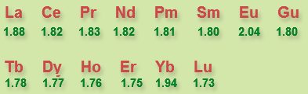

The diagrammatic representation of lanthanide contraction is shown below.

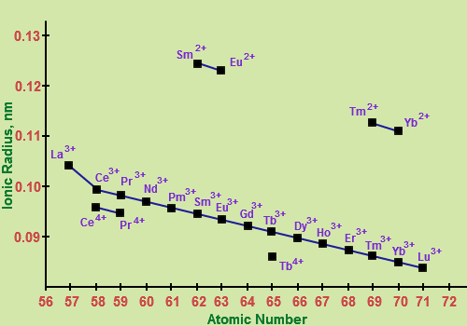

## *Cause*

The cause of lanthanide contraction is generally attributed to imperfect shielding of one 4f electron by another in the same shell. The imperfect shielding of one f electrons is due to the shape of f-orbitals, which is very much diffused. As the atomic number increases, the nuclear charge increases by unity at each step, while no comparable increase in the mutual shielding effect of 4f electrons occurs. This causes a contraction ion the size of the 4f subshell. Consequently the atomic and Ionic size goes on decreasing systematically from La to Lu.

Decrease in atomic radii is continuous but not regular. The decrease is much more in case of first six elements than in the subsequent elements. Hence the properties of lanthanides compounds show divergence from regularity.

## *Effects*

The effect of lanthanide contraction is of sufficient magnitude to cause the elements which follow in the third transition series to have sizes very similar to those of the second row of transition elements. The normal increase in size from Sc to Y to La disappears after the lanthanides. Thus the pairs of elements such as Zr-Hf, Nb-Ta, Mo-W have nearly identical sizes. They have similar chemical properties and their separation is very difficult.

The effect of lanthanide contraction is also important in the chemistry of lanthanides themselves. A general decrease in ionic radii on crossing the series results in a corresponding increase in the polarizing power of the ions and in the stability of the complex ions. Increasing polarizing power makes the hydroxides less and less basic on crossing the lanthanides. For example, La(OH)3 is most basic whereas Lu(OH)3 is less basic.

## *Consequences*

Lanthanide contraction plays an important role in explaining many properties of lanthanides.

1. **Electronegativity -** There is a slight increase in elctronegativity of trivalent ions.
2. **Ionic radius -**There is a steady decrease in the ionic size.
3. **Basic nature -** Basic nature also decreases from Ce(OH)3 to Lu(OH)3. Due to lanthanide contraction the decrease in the size of the cation increases the covalent character between the lanthanide ion and the hydroxide ion thereby reducing the basic character of the lanthanide hydroxides.
4. **Color -** The lanthanide metals are slightly white but the trivalent lanthanide ions are colored both in the [solid state](http://chemistry.tutorcircle.com/inorganic-chemistry/solid-state.html) and in aqueous solution.
5. **Magnetic properties -** La3+ and Lu3+ having no unpaired electron these do not show paramagnetism while all other tripositive ions of lanthanides are paramagnetic.

Actinide contraction

There is a regular decrease in Ionic radii with increase in atomic number from actinium to lawrencium. This is called actinide contraction. This contraction is similar to lanthanide contraction. The actinide contraction is caused due to to imperfect shielding of one 5f electron by another in the same shell. Thus, as we move along [actinide series](http://chemistry.tutorcircle.com/inorganic-chemistry/actinide-series.html) the nuclear charge and the number of 5f electrons increase by one unit.

## *Comparison*

The difference between lanthanides and actinides are listed below.

|  |  |  |
| --- | --- | --- |
| **S.No** | **Lanthanides** | **Actinides** |
| 1 | Lanthanides occur in nature. | Actinides are synthetic. |
| 2 | Lanthanides form [spectral lines](http://chemistry.tutorcircle.com/inorganic-chemistry/spectral-lines.html) which is less intense. | Spectral lines formed by actinides are about ten times as intense as those formed by the lanthanides. |
| 3 | +3 oxidation state is the most stable oxidation state formed by lanthanides. | Though all the actinides form +3 oxidation state, it is not the most stable especially for the first four actinides - Th, Pa, U and Np. The stable +4 state is much more common than in the lanthanides. |
| 4 | In lanthanides the 4f orbitals are burried deep inside the atom, totally shielding by outer orbitals and thus unable to take pat in bonding. | The 5f orbitals in the actinides extend into space beyond the 6s and 6p orbitals and participate in bonding. |

## *Uses* Lanthanides

1. Ceric sulphate is used as an [oxidizing agent](http://chemistry.tutorcircle.com/analytical-chemistry/oxidizing-agent.html) in [volumetric analysis](http://chemistry.tutorcircle.com/analytical-chemistry/volumetric-analysis.html).
2. Cerium salts are also used in dyeing cotton in lead accumulators and also catalysts.
3. Oxides of neodymium and praseodymium are used for making colored glasses for goggles.

### Actinides

1. Thorium is used in atomic reactors as fuel rods and in the treatment of cancer. A mixture of thorium and cerium nitrate in the ratio of 99:1 is used for making incandescent gas mantles.
2. Uranium is used as nuclear fuel. Its salts are used in glass industry, textile industry and also in medicines.
3. Plutonium is used as fuel for atomic reactors as well as in atomic bombs.