**COMPARATIVE STUDY OF ANTIOXIDANTS ON THE QUALITY OF SESAME OIL**

**Project report**

**Submitted to**

**MAHATMA GANDHI UNIVERSITY**

**FOR THE PARTIAL FULFILMENT OF**

**THE AWARD OF THE DEGREE OF THE**

**BACHELOR OF SCIENCE IN CHEMISTRY**



**BY**

**Anagha A.B**

**III B.Sc. INDUSTRIAL CHEMISTRY**

**REG NO: 170021040556**

**MARCH 2020**

**DEPARTMENT OF CHEMISTRY**

**ST. PAUL’S COLLEGE**

**KALAMASSERY**

# DECLARATION

I, ANAGHA A.B, hereby declare that the project entitled ‘A COMPARATIVE STUDY OF ANTIOXIDENTS ON THE QUALITY OF SESAME OIL’ is an authentic record of the work carried out by me under the guidance of Texin Joseph, Department of Chemistry, St.Paul’s College, Kalamassery and has not been included in any other project submitted for the award of any degree.

ANAGHAA.B

B.Sc. Final IndustrialChemistry

St.Paul’sCollegeKalamassery

# ACKNOWLEDGEMENT

I have great pleasure and excitement in presenting the project report undertaken by me with the help of Almighty god who had done everything in our life to achieve success.

I have great pleasure to express my deepest gratitude and sincere thanks to my guide, Texin Joseph, Department of Chemistry, St. Paul’s College, Kalamassery, for his esteemed guidance with all scientific freedom, constant encouragement and discussion in every phase of my work.

I record my deep sense of gratitude to Dr. Mareena Benny, Asst. General Manager QA/R&D; Arjuna Natural extracts Ltd, Edayar for providing the facilities for doing the project work.

I record my heartfelt thanks to my teachers and my parents for their constant encouragement during the period of study and support.

Last, but not the least, I do thank Mr. Rajesh and other coworkers of Arjuna Natural Extracts Ltd, Edayar, and all my friends for their immense friendliness and timely help.

Anagha A.B

## ABOUT THE COMPANY ARJUNA NATURAL EXTRACTS LIMITED

1. Since 1989
2. Manufacturing more than 40 herbal, spice and essential oilextracts
3. Asia’s largest manufacturer of Omega 3 fatty acidconcentrates
4. Marketing in more than30countries
5. Global standard and Globalreach

## AWARDS FOR EXCELLENCE

1. Certificate of honor for export achievement from Spices Board of India Government
2. Best Entrepreneur Award fromKSIDC
3. Entrepreneur of the year Award fromBIMS
4. Highest Export Award from newly developed market from SpicesBoard

## THE MAJOR PRODUCTS

1. Amla Extract
2. AshwagandhaExtract
3. Brahmi Extract
4. Green TeaExtract
5. TulsiExtract
6. Triphala Extract
7. Ginger DryExtract
8. CurcuminPowder

# CONTENTS

|  |  |
| --- | --- |
| **SL NO.** | **CHAPTER** |
| 1 | INTRODUCTION |
| 2 | AIM AND SCOPE OF WORK |
| 3 | REVIEW OF LITRATURE |
| 4 | ANALYSIS METHOD |
| 5 | EXPERIMENTS AND MATERIALS REQUIRED |
| 6 | RESULT AND DISCUSSION |
| 7 | SUMMARY AND CONCLUSION |
| 8 | BIBLIOGRAPHY |

**COMPARATIVE STUDY OF ANTIOXIDANTS ON THE QUALITY OF SEASAME OIL**

# INTRODUCTION

Nature has provided us with a rich store house of herbal remedies to cure most diseases. Oils belong to the group of naturally occurring compounds called lipids. Lipids are those constituents of animals and plants which are soluble in organic solvents such as ether, chloroform, carbon tetrachloride, benzene, hexane etc., but insoluble inwater.

##### FATS ANDOILS

Fats and oils are the most important lipids found in nature. They are one of the three major ‘food factors’ needed for human body, the other two being proteins and carbohydrates. Fats and oils are widely distributed in food and are of great nutritional value. They provide concentrated reserve of energy in animal body for maintaining optimum body temperature.one gram of metabolized fat or oil yields 9 kcal, while the corresponding value for carbohydrate and protein are 4kcal and 5.5 kcal respectively. Not only the edible fats and oils occupy a place of pride in human diet but they also find use as raw material for the manufacture of soaps and synthetic detergents, paints and varnishes, polishes, glycerol, lubricants, drying oils cosmetics, printing inks, linoleum oil cloth and pharmaceuticals. At the present time the human race uses as estimated 40 million tons a year of fats and oils which reflects both their nutritional and industrial importance.

##### STRUCTURE OF FATS ANDOILS

Animal and vegetable fats and oils have similar chemical structures. They are tri-esters formed from glycerol and long-chain carboxylic acids (often called fatty acids).

|  |  |  |  |  |
| --- | --- | --- | --- | --- |
|  |  |  |  | O |
|  |  |  |  |  |
| CH2-OH | O | CH2-O-C-R | | |
|  |  |  | | |
| CH-OH + 3R- | C-OH | CH-O-C |  | -R +3H2O |
| CH2-OH  glycerol | fatty acid | CH2-O-C-R | | |

O



A fat or oil (triglyceride)

A tri-ester of glycerol is called a triglyceride or glyceride. If all the R groups in the above general formula are identical, the tri-ester is designated as a Simple glyceride and if they are not, then is known as mixed glyceride. Most natural fats and oils are mixed triglycerides having two or three different fatty acid groups.

The terms ‘Fat’ and ‘Oil’ are more or less conventional and nowadays used in a very general fashion. Chemically common oils and fats are assortment of saturated and unsaturated triglycerides present in varying ratios. The apparent distinguishing difference between the two classes of compounds is their physical state.

At ordinary temperature, fats are solid or semisolid glycerides, while oils are liquids. But, a given sample of glycerides (say ghee), may be a ‘fat’ in winter and an ‘oil’ in summer. In fact, it would be more advisable to use the term fat for both these classes ofsubstances.

##### PHYSICALPROPERTIES

* + 1. Oils and fats may be either liquids or non-crystalline solids at roomtemperature.
    2. When pure, they are colorless, odour less and tasteless. The characteristic colours, odours and flavours associated with natural oils and fats are imparted to themby
    3. foreign substances. For example, the yellow colour of butter is due to the presence of the pigment carotene; and the taste of butter is due to the following two compounds which are produced by bacteria in the ripening ofcream.

OO O



CH3-C-C-CH3 CH3-C-CHOH-CH3

Diacetyl 3hydroxyl-2-butonone

* + 1. They are lighter than and insoluble in water, therefore, it forms the upper layer when mixed with it. They are readily soluble in organic solvents like diethyl ether, acetone, alkynes, benzene, chloroform, carbon tetra chloride and carbondi-sulphide.

They readily form emulsions when agitated with water in the presence of soap, gelatin or other emulsifiers.

* + 1. They are poor conductors of heat and electricity, therefore, they serve as excellent insulators for the animalbody.

##### CHEMICALPROPERTIES

The reactions of oils and fats are the reactions of triglycerides or tri-esters of glycerol. Thus, they can undergo hydrolysis at all the three ester groups. Also, the chains of the acid components of glycerides may contain one or more double bonds. Therefore, the unsaturated glycerides give the addition and oxidation reactions characteristic of alkenes at the seats of these double bonds.

* + 1. **Hydrolysis:** Triglycerides are easily hydrolysed by enzymes called lipases (catalysts) in the digestive tracts of human beings and animals, to give fatty acids andglycerol.

The fatty acids so produced play an important role in the metabolic process in the animal body



|  |  |
| --- | --- |
| O | O |
| CH2-O-C-R | CH2-OH +R-C-OH |
| O | O |
| CH-O-C-R’ + 3H2O | CH-OH +R’-C-OH |
| O | O |
| CH2-O-C-R” | CH2-OH +R’’-C-OH |

triglyceride glycerol fattyacids



* + 1. **Saponification:** When triglycerides are hydrolysed (saponified) by alkalis, glycerol and the salts of fatty acids are produced. Generally, the sodium or potassium salts are obtained which are termed assoaps.
    2. **Hydrogenation or hardening of oils:** unsaturated glycerides react with hydrogen in the presence of a metal catalyst (usually nickel) to give saturated glycerides. This reaction is similar to the catalystic hydrogenation of alkenes. The process of hydrogenation which results in hardening of an oil owing to the formation of fat, is often referred to as Hardening. This reaction is used commercially to harden vegetable oils for the production of cooking fat (vegetable ghee or margarine). Hardened oils are also extensively used for making soaps andcandles.
    3. **Hydrogenolysis (Reduction to Alcohols):** upon treatment with hydrogen at high pressure and temperature in the presence of copper chromite (CuCr2O4) as catalyst, glycerides are split up like other esters. The products are glycerol and the reduction products of the fatty acid, along chain alcohols. Thus, glyceryl tri stearate forms glycerol and octadecyl alcohol.

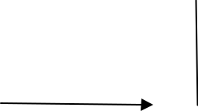

|  |  |  |
| --- | --- | --- |
| O |  |  |
| CH2-O-C-C17H35 |  | CH2-OH |
| O | CuCr2O4 |  |
| CH-O-C-C17H35 | O | CH-OH +C17H35-CH2OH |
| + H3 250 C pressure |
| O |  | n- octadecanol |
| CH2-O-C-C17H35 |  | CH2-OH |
| Glyceryl tri-stearate |  | Glycerol |

This reaction which causes the cleavage of the fat by hydrogenation to yield glycerol and a higher aliphatic alcohol, is termed as Hydrogenolysis. The long-chain alcohols produced by the hydrogenolysis of glyceride are used in the manufacture of synthetic detergents.

* + 1. **Rancidity (Hydrolysis-Oxidation):** The term rancid is applied to any fat or oil that developes a disagreeable odour when left exposed to warm, moist air for any length of time. Rancidity is chiefly caused by hydrolysis of the ester links and oxidation of double bonds of the tri-glycerides. The lower molecular weight acids that are produced are volatile and impart an offensive odour to fat oroil.

**Hydrolytic Rancidity:** This type of rancidity is due to the liberation of lower fatty acids by hydrolysis of ester links of triglycerides. Hydrolytic rancidity is particularly applicable to butter. Under moist and warm conditions, hydrolysis of the glycerides in butter liberates the odours of butyric acid, caproic acid, caprylic acid and capric acid.

|  |  |
| --- | --- |
| O | O |



|  |  |  |
| --- | --- | --- |
| CH2-O-C-CH2 CH2 CH3 | CH2OH | CH2CH2CH2-C-OH |
| O |  | O |
| +3H20 |  |  |
| CH-O-C-CH2 CH2CH2CH2 CH3 | CHOH + | CH3(CH2)4-C-OH |
| O |  | O |
| CH2-O-C-CH2 CH2CH2CH2CH2CH2 CH3 | CH2OH | CH3(CH2)6-C-OH |
| A butter tri-glyceride | glycerol butyric,caprotic,caprylic acid | |

Micro organisms present in the air provide the enzymes that catalyse the hydrolytic process. Rancidity so caused can be prevented by keeping butter covered in arefrigerator.

b. **Oxidative Rancidity:** It occurs in tri-glycerides containing unsaturated acid components. It is believed that first the ester linkages are hydrolysed to yield unsaturated acids.The acids so produced are subject to oxidative cleavage at the site of the double bonds forming short chain offensive aldehydes and acids.Oxidation leading to rancidity in fats and oils is catalyzed by the presence of certain metallic salts. The addition of antioxidants will preserve edible fats for long periods of storage. Two antioxidants occurring in natural fats are Vitamin E and Ascorbic acid.

**ANTIOXIDANTS**

An antioxidant is a molecule capable of preventing the oxidation of other molecules. Oxidation is a chemical reaction that transfers electrons from a substance to an oxidizing agent. Oxidation reactions can produce free radicals which start chain reactions to damage the cell. Antioxidants terminates these chain reactions by removing the free radical intermediates being oxidized by themselves. The few important antioxidants are TBHQ, BHA, BHT, VIT.E, Ascorbic acid, Glutathione, Melatonin etc.

## TBHQ

It is Tertiary Butyl Hydro Quinone. It is the synthetic grade antioxidant which is used in stabilizing various vegetable oils, fats and foods against oxidative deterioration. Thus, it regards the development of rancidity and extends its storage life. It has an outstanding stabilizing effect in unsaturated fatty acids, vegetable oils and animal fats. It is also advantageous in oils, nuts, buffer etc. It is a white crystalline powder. Molecular weight is

* 1. Melting point is128o.

CH3

### OH C-CH3

CH3

OH

#### ADVANTAGES:

* + - Excellent antioxidant potency in oils andfats.
    - Reduction in nutritionallosses
    - Extended storage life.

## BHA

It is Butylated Hydroxy Anisole. It is a phenolic compound generally added to foods to preserve fats. It is found under butter, meat, cereals, chewing gums and cosmetics. It is a white or yellowish waxy solid and has an aromatic odour.

#### MECHANISM OF ACTION:

Oxygen reacts with BHA rather than oxidizing fats or oils, by protecting them from spoiling.

CH3

OH C-CH3

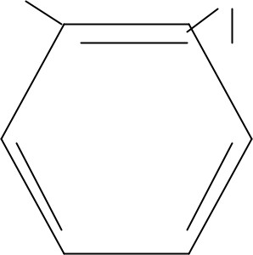

CH3

### O CH3

**VITAMIN E**

Vitamin E is the collective name for a set of eight related tocopherols and tocotrienols, which are fat soluble vitamins with antioxidant properties. Of these, tocopherols is the most important form due to its highest bio availability. As a result, body will be prefentiably absorbing and metabolizing this form. It is used for the treatment of prostate cancer and congenital heart diseases. Main food sources are egg, milk, nuts, spinach, unheated vegetable oils etc..

# 2. AIM AND SCOPE OF THEWORK

The main objective of this work is:

#### Comparative study of antioxidants on the quality of sesame oil

1. To determine AcidValue
2. To determine PeroxideValue
3. To determine AnisidineValue
4. UsingG.C
5. UsingU.V

##### Scope:

1. This analysis is for testing the ability ofantioxidants
2. To find out which is the betterantioxidant
3. How these antioxidants decrease the rancid effect ofoils

# 3. REVIEW OF LITERATURE

## SESAME OIL

#### SOURCES

Sesame oil is the fixed oil obtained by expression from seeds of Sesamum Indicium Linn. It comes under the family of Pedaliaceae, believed to be indigenous to tropical Africa and is cultivated in India, China, and Nigeria etc.

#### MANUFACTURE

The sesame seeds are protected by a capsule which does not burst until the seed completely ripens. The ripening time tends to vary, for this reason the farmers cut plants by hand and place them together in upright position to carry on ripening for a few days. The seeds are only shaken out onto a cloth after all capsules areopened.

|  |  |
| --- | --- |
| **CONSTITUENTS** |  |
| The seeds contain  Fixed oil | 45-55% |
| Proteins | 15-20% |
| Mucilage | 4% |

It also contains about 21% of glycerides of oleic, linoleic, palmitic, stearic and myristic acids an also contains a crystalline substance, sesamine and a phenolic substance, sesamol. Sesamoline, a lignan of the unsaponifiable portion of the oil. Sesamoline on hydrolysis gives Sesamol, a phenolic constituent responsible for the excellent stability of the oil.

|  |  |
| --- | --- |
| **FATTY ACIDS** | PERCENTAGE |
| Palmitic | 7-12% |
| Palmitoleic | 0.5% |
| Stearic | 3.5-6% |
| Oleic | 35-50% |
| Linoleic | 35-50% |
| Linolenic | 1% |
| Eicosenoic | 1% |

#### VARIOUS NAMES

###### SYNONYMS

Ellu-ennaGingerllyoil TilertelMithutelTilkatelNallennai

###### REGIONAL NAMES

Malayalam Bengali Gujarathi Hindi Kannada Tamil

## IDENTIFICATION TESTS

On shaking 1ml of sesame oil with a solution of 0.5g of sucrose in 10ml of hydrochloric acid for half a minute, the acid layer becomes bright red changing to dark red on standing (due to the presence of sesamol). This is the distinction test for sesame oil from others.

## PROPERTIES

Colour Consistency Odour Taste

Pale yellow Oily liquid

Somewhat pleasure Bland

## USES

1. Body massage: It can penetrate the skin easily, so used in oil massaging. It also enhances the bloodcirculation.
2. Hair Treatment: it darkens the hair and reduces the bodytemperature.
3. Food Manufacture: Mainly used inpickles.
4. Drug Manufacture: In Ayurvedic drugs likethailams.
5. For Worship: In temples, it is used in lamps and inpoojas.
6. Industry: As a solvent in injected drugs, cosmetic carrier oil, as insecticides, low grade oils used in soaps, paints andlubricants.

## ANALYSISMETHOD

About 30 gm of the sesame oil is taken in the four different glass bottles, A, B, C and D. Add

0.5 gm of TBHQ in bottle A, BHA in bottle B, Vitamin E in bottle C and the last bottle is kept with the oil alone without any antioxidants. Take 5 gm of oil from each of A, B, C, D. Find out its Acid Value, Peroxide value, Anisidine Value, U.V. and G.C. Heat the four bottles in the water bath keeping the temperature constant at 100 degree. After 1 hour, the experiment is repeated. The process is continued at successive hours. Thus, we get the experiment readings at 4 successive hours and at the 0 hour. From this, we can analyse the effect of different antioxidants on the quality of sesameoil.

# MATERIALS AND EXPERIMENTS

## CHEMICAL PARAMETERS

#### DETERMINATION OF ACID VALUE

The acid value of an oil is the number of mg potassium hydroxide required to neutralise 1 g oil. The oil is dissolved in an appropriate solvent, ethanol and diethyl ether in 1:1 ratio, after which the solution is titrated with sodium hydroxide solution.

The amount of sodium hydroxide solution consumed in a measure of acidity of anoil.

#### Reagents

1. 96% ethanol and diethyl ether (1:1ratio)
2. 0.1NNaOH
3. 0.1 N Oxalicacid
4. Phenolphthalein indicator

#### Apparatus

1. Burette 50ml-1
2. Pipette 20ml-2
3. Erlenmeyer conical flask 250ml-4
4. Measuring jar 100ml-1
5. Electronicbalance
6. Dropper-2
7. Standard Flask 100ml-3
8. Weighingbottle-1
9. Beaker 50ml-1

## PROCEDURE

#### Preparation of standard sodium carbonate solution:

Dissolve 0.53 g of anhydrous sodium carbonate using distilled water in a 100 ml standard flask and make up to the mark.

#### Standardisation of Hydrochloric acid:

Fill the burette with HCl (0.1 N i.e., 1 ml con. HCl to 100 ml) and titrate against 20 ml of sodium carbonate using methyl orange as indicator. End point is the change of golden yellow to pale red orange. Repeat the titrations till concordant values are obtained.

#### Standardisation of alcoholic Potassium Hydroxide (alc. KOH):

Dissolve 0.56 g KOH pellets in alcohol and made up to 100 ml in a standard flask. Titrate 20 ml against standard HCl, using methyl orange as indicator. Repeat the titrations till concordant values are obtained.

Weigh approximately 1-2 g well mixed sample into 250 ml Erlenmeyer flask. Add 50-100 ml toluene-isopropyl alcohol mixture and 0.1 ml phenolphthalein solution. Titrate with 0.1 N alc. KOH until permanent faint pink appears and persists.

## CALCULATION

Acid Value= Vol. Of KOH soln. *Normality of alc.KOH * 56.1/Wt. Of the sample.

## DETERMINATION OF PEROXIDE VALUE

|  |  |  |  |
| --- | --- | --- | --- |
| **Apparatus** | | | |
| 1. | Weighing Bottle | - | 1 |
| 2. | Standard Flask |  |  |
|  | 250 ml | - | 2 |
|  | 100 ml | - | 3 |
| 3. | Stopped Conical Flask | - | 2 |
| 4. | Measuring jar |  |  |
|  | 100 ml | - | 1 |
|  | 50 ml | - | 2 |
|  | 10 ml | - | 1 |
| 5. | Graduated test tubes 5 ml | - | 2 |
| 6. | Pipette 20 ml | - | 1 |
| 7. | Pipette 1 ml graduated | - | 1 |
| **Reagents** | |  |  |

* 1. . Potassium iodide solution –saturated
  2. 0.1N Sodium thiosulphatesolution
  3. 1 NHCl
  4. Distilled water
  5. Starch solution
  6. KIcrystals
  7. Potassium dichromatecrystalal

|  |  |
| --- | --- |
| 8. Potassium iodide | - 5% |

## PROCEDURE

#### Preparation of potassium dichromate solution:

About 1.2 g of potassium dichromate is accurately weighted. It is transferred into a 250 ml standard flask. It is dissolved in water and made up to the mark.

#### Preparation of thiosulphate solution:

20 ml of the made up dichromate solution is pipetted into a conical flask and about 3 ml of pure con. HCl is added. About 10 ml of 5% of KI solution is added. Then, it is diluted to 100 ml with the distilled water titrated against 0.1 N sodium thiosulphate solution taken in the burette. The addition of sodium thiosulphate is continued until the solution is pale yellowish colour. About 2 ml of starch solution is added and the titration is continued until the blue colour is just dis changed. Titrations are repeated till concordant values are obtained.

Weigh 5 g of the sample into a 250 ml of stoppered conical flask. To this, add 30 ml of 2:3 chloroform-Acetic acid solution and swirl to dissolve. Then add 0.5 ml of saturated potassium iodide solution from the pipette and close the flask with stopper. Let it stand with occasional stirring for one minute to that add 30 ml distilled water and slowly titrate with 0.1 N sodium thiosulphate solution with vigorous shaking till the yellow colour almost disappears. Add 0.5 ml of 1% starch solution. Shake vigorously to release all iodine from chloroform layer until blue colour just disappears. Conduct a blank iteration.

|  |  |  |  |
| --- | --- | --- | --- |
| **Calculation:** |  |  |  |
| Mass of potassium dichromate | | = Wg | |
| Normality of Potassiumdichromatesolution = | |  | w*4/49.04 g = N |
| Volume of Potassium dichromate solution | | = | 20 ml |
| Volume of thiosulphate used up | | = | V1 |
| Let the normality of sodium thiosulphate be | | = N1 | |
| **Determination of peroxide value:** | |  | |
| = | N*20 |  | |

|  |  |  |
| --- | --- | --- |
| N1*V1 |  |  |
| SON1 | = | N*20/V1 |

Peroxide value = Milli equivalent peroxide /kg of the sample= S*N1*1000/Wt. of the sample ingm.

S - Ml. 0.1 N Sodium thiosulphate N1 - Normality of sodium thiosulphate solution

## DETERMINATION OF ANISIDINE VALUE

During the drying of oils methylene groups present in the linoleic acid component of the unsaturated glyceride is readily attacked by oxygen of the air to form hydro peroxy group at these sites. These hydro-peroxy groups then reacts with unchanged methylene groups in other glyceride molecules to form peroxide bridges. These peroxides are unstable and they tend to decompose to form aldehydes and ketones. The content of aldehyde, principally 2- alkenal in the oil can be measured to further to assess its degree of oxidation. This is called Anisidine value. It is measured by determining the absorbance of the sample in iso-octane at 350 nm. It is used to track the quality of same oil.

#### Reagents

|  |  |  |  |
| --- | --- | --- | --- |
| 1. | P. Anisidine | - | AR Grade |
| 2. | Glacial Acetic Acid | - | AR Grade |
| 3. | Iso-Octane | - | AR Grade |

**Apparatus**

|  |  |  |  |
| --- | --- | --- | --- |
| 1. | Weighing bottle | - | 1 |
| 2. | Standard Flask 25 ml | - | 3 |
| 3. | Measuring Cylinder 60 ml | - | 2 |
| 4. | Pipette 10 ml | - | 2 |

**Procedure**

Weigh about 0.5 gm of the sample into a 25 ml standard flask and dilute the volume with iso-octane. Measure the absorbance [ab] of the solution at 350 nm using the solvent as a blank. Pipette out 5 ml of the solution into a tube and 5 ml of the solvent to another tube. Add exactly 1 ml of the P-anisidine reagent (0.25% of P-anisidine in Glacial Acetic acid) to each and shake well. After exactly 10 minutes, measure the absorbance of the solution in the first test tube in a cell at 350 nm using the solution from the second as the blank [as].

## Calculation

The P-anisidine value is given by the formula,

25* (1.2 as-ab)/ Wt. of the samples in gm

## GAS CHROMATOGRAPHY

Gas chromatography, specifically gas-liquid chromatography involves a sample being vaporized and injected on to the head of the chromatographic column. The sample is transported through the column by the flow of inert, gaseous mobile phase. The column itself contains a liquid stationary phase, which is absorbed on to the surface of an inert solid.

## INSTRUMENTAL COMPONENTS

#### Carrier Gas

Carrier gas may be chemically inert. Commonly used gases are Nitrogen, Helium, Argon and Carbon dioxide. It depends on the nature of detectors.

#### Sample Injection Port

The most common injection method is where a micro syringe is used to inject the sample through a rubber septum into a flash vaporizer port at the head of the column. The temperature should be kept at 50 degree.

#### Columns

There are two general types of columns, packed and capillary columns. Packed columns contain finely divided inert solid support material counted with liquid stationary phase. Capillary columns have an internal diameter of a few tenths of a millimeter.

#### Detectors

There are many detectors which are used in G.C. different detectors will give different selectivity.

## UV SPECTROSCOPY

UV spectroscopy is a reliable and accurate analytical laboratory assessment procedure that allows for the analysis of a substance specifically, it measures the absorption, transmission etc. it is the measurement of attenuation of beam of light after it passes through the sample.

## INSTRUMENTATION

UV-Visible spectral range is approximately 190-900 nm. The short wavelength limit for a simple UV-visible spectrometer is absorption of UV wavelength less than 180 nm by atmospheric gases pursing a spectrometer with nitrogen gas extends this limit to 175 nm. Working beyond 175 nm requires a vacuum spectrometer and a suitable UV light source. The long wavelength limit is usually determined by the wavelength response of the detector in the spectrometer. Commercial UV spectrometer extends the measurable spectral range into the NR region as far as 3300nm.

The light source is usually a deuterium discharge lamp for UV measurements. The instruments automatically swamp lamps when scanning between the UV and visible regions. The wavelength of these continuous light sources is typically dispersed by a holographic grating in a single or double mono-chromator. The spectral band pass is then determined by the mono-chromator slit width. Spectrophotometer and optical components are optimized to reject the stray light, which is one of the limiting factors in qualitative absorbance measurements. The detector in the single detector instrument is a photo diode, phototube, UV visible NIR spectrometers utilize the combination of a PMT and a Peltier cooled PbS IRdetector.

Most commercial UV absorption spectrometers use one of the three overall optical designs, a fixed or scanning spectrometer with a single light beam and a simple holder for simultaneous measurements of p and p0. In single beam and double beam spectrometers, the light from a lamp is dispersed before reaching the sample cell. In an array detector instrument, all wavelengths pass through a sample and all the dispersing element is between the sample and array detector. The main instrumentsare:

1. Single beam UV-visspectrophotometer
2. Dual beam UV-visspectrophotometer
3. Arraydetector

#### ADVANTAGES OF UV

1. Ease of operation
2. Dataacquisition
3. Color measurement
4. Polymer analysis
5. Biochemistry andBiotechnology
6. Elementaldetection

# RESULT AND DISCUSSION

## ACID VALUE OF THESAMPLES

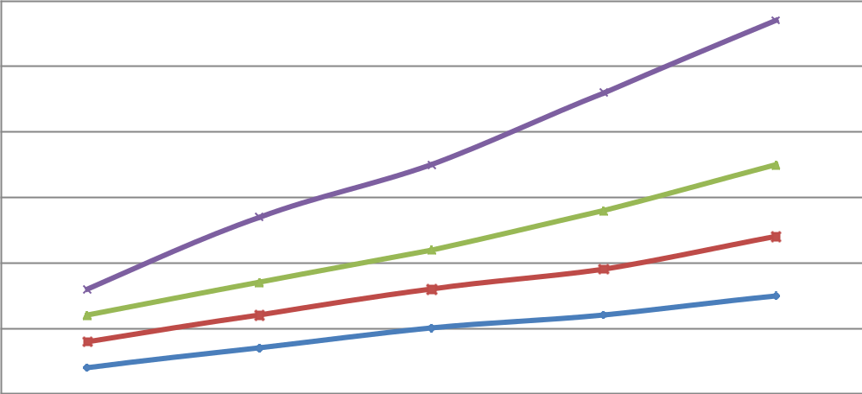60

50

40

30

20

10

0



|  |  |  |  |  |
| --- | --- | --- | --- | --- |
| 0 | 1 | 2 | 3 | 4 |
|  | **TIME IN HOURS** | |  |  |
| TBHQ | VIT.E | BHA | CONTROL |  |

## PEROXIDE VALUE OF THESAMPLES

|  |  |  |  |  |  |
| --- | --- | --- | --- | --- | --- |
|  | 5.2 |  |  |  |  |
|  | 5.1 |  |  |  |  |
|  | 5 |  |  |  |  |
|  | 4.9 |  |  |  |  |
| **VALUE** | 4.8 |  |  |  |  |
|  |  |  |  | TBHQ |
| **PEROXIDE** | 4.7 |  |  |  |  |
|  |  |  |  | VIT.E |
| 4.6 |  |  |  | BHA |
|  | 4.5 |  |  |  | CONTROL |
|  | 4.4 |  |  |  |  |
|  | 4.3 |  |  |  |  |
|  | 4.2 |  |  |  |  |
|  | 0 | 1 | 2 | 3 | 4 |

**TIME IN HOURS**

## ANISIDINE VALUE OF THESAMPLES

**ANISIDINE VALUE**

20

18

16 5

17.390

14

12

**VALUES**

1

11.323

10 7

10.486

2

9.26

8 3

6 4

4

2

0

1 2 3 4

**AGENTS**

## SPECTRUM OF SESAMEOIL

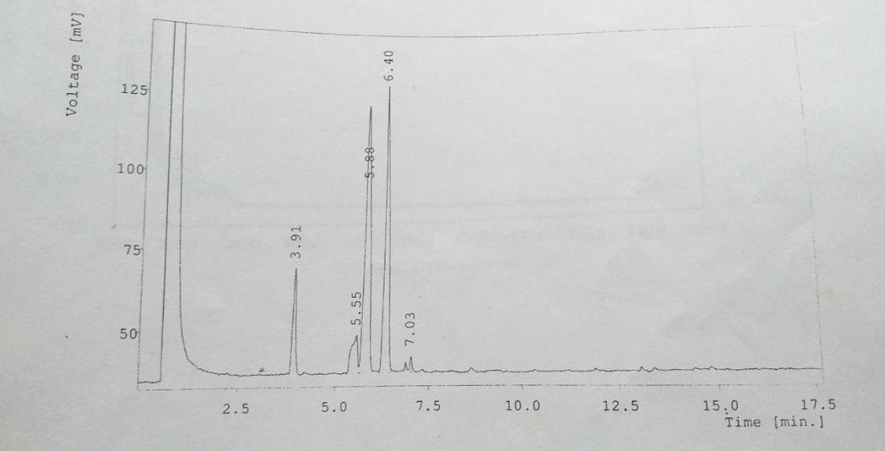

* 1. **SPECTRUM OF SESAMEOIL-MIXTURE**

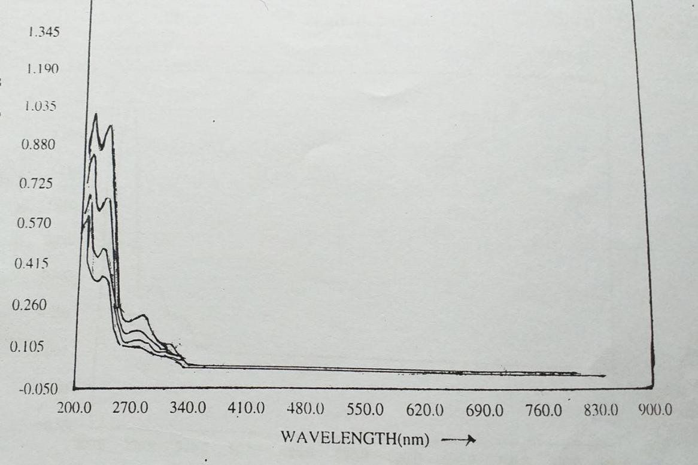

* 1. **SPECTRUM OF SESAMEOIL-CONTROL**

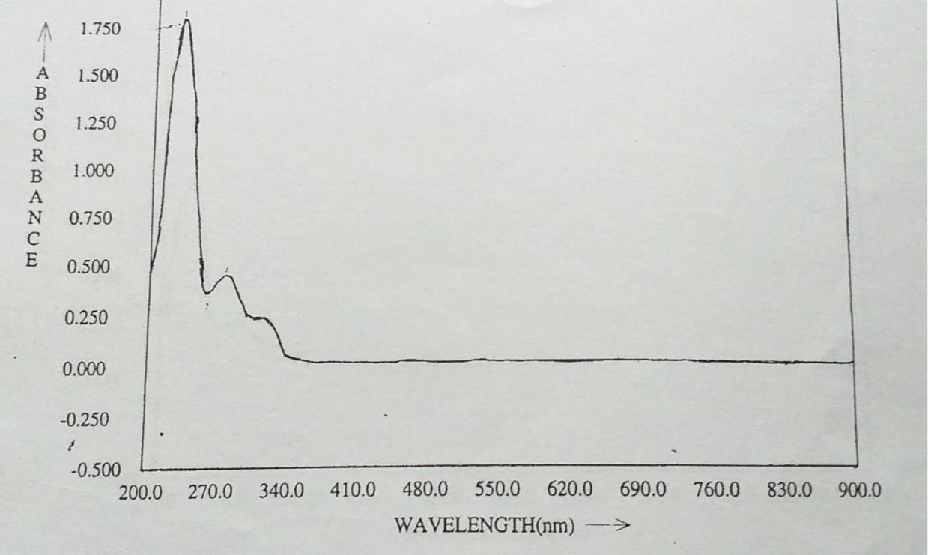

**SPECTRUM OF SESAME OIL-VITAMIN E**

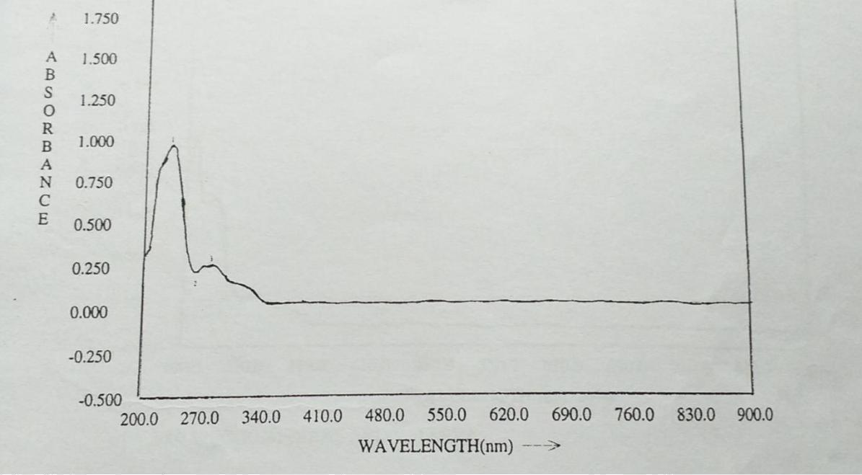

1. **SPECTRUM OF SESAMEOIL-BHA**

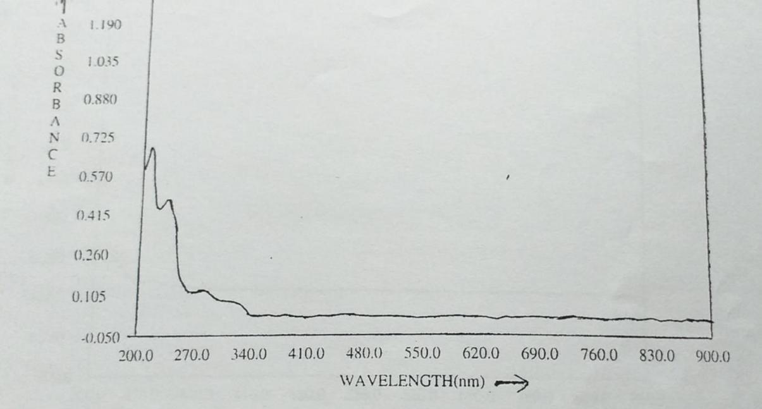

1. **SPECTRUM OF SESAMEOIL-TBHQ**

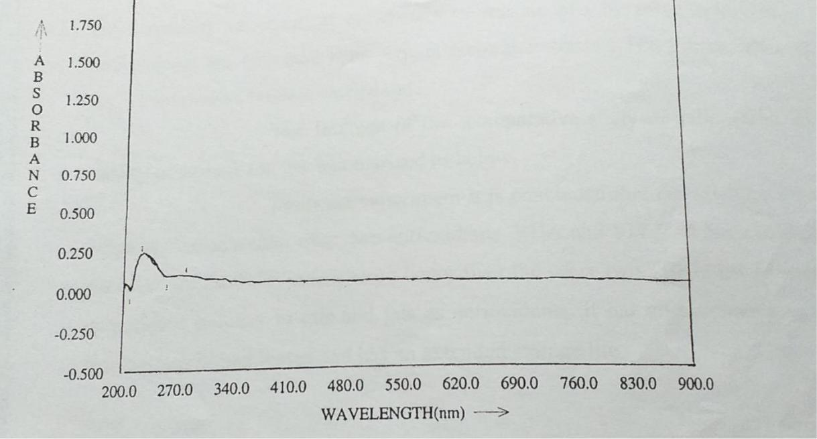

**SUMMARY**

The oil is collected from oil mills with the objective of assessing the variability of chemical parameters of sesame oils by using antioxidants. The antioxidants are collected from Arjuna Natural Extracts L.T.D, Edayar, from where my whole project work was carried out.

The findings of the ‘Comparative Study of Antioxidants on the quality of Sesame Oil’ are summarized below:

From the experiment, it is concluded that the TBHQ is the most better antioxidant than other two antioxidants, BHA and VITAMIN E. It has a tendency to decrease the rancidity much more better than the other two. TBHQ has an excallent antioxidant potency in oils and fats. It has an excellent stability and reduces nutritional losses. It has an extended storage life.

# BIBLIOGRAPHY

* 1. Aiger K.N and Kolamal M, 1960, Pharmacognosy of Ayurvedic Drugs, Pharmaconosy unit, Ayurvedic College,Trivandrum
  2. B.S. Bahl, ArunBahl, 1983, Advanced OrganicChemistry
  3. HMA Awatif, 62(3), p-269, FoodChemistry,1998
  4. LV Cocks and C.VanRede, 1966, Laboratory Hand Book for Oil and FatAnalysis
  5. MA Iyenger, 1981, Study of CrudeDrugs
  6. Prof. Satish Agarwala and Dr. R.C. Agarwala, 1996, Advanced OrganicAnalysis
  7. T.E.Wallis, 1985, Text Book OfPharmacognosy